When Larry met Sally

Scarcity. The very term conjures up images of long lines of people hoping to get food from empty shelves in the old Soviet Union or the proverbial barren landscape devoid of growth and warmth that features just as often in romantic poems from a hundred years ago as in the dystopian motion pictures of modern times. But we while we should continue to enjoy the melodramatic images of such works of art as T.S. Eliot’s the <em>Wasteland</em> or Suzanne Collins' the <em>Hunger Games</em>, the word scarcity should actually summon mundane images of our day-to-day lives since each of us lives with scarcity simply because we can't get everything we want. And for such humdrum settings such as one's ordinary life being a vehicle to convey economic (or any kind of) wisdom, no better medium exists than the standup comedy routine at the hands of a skillful comedian.
The specific comedian that will be the featured player of this installment is Larry Miller. Larry is a well-known comic who is famous for some of the most hilarious and insightful routines like the 5 Levels of Drinking or The Secret of Skiing. He is also, by his own admission, a character actor and, to anyone whose had the pleasure to see him in Pretty Woman, For Richer or Poorer, or 10 Things I Hate About You, a very good one at that.
Back to economics. Larry has a wonderful way of encapsulating the essential character of things within a very funny message (his mannerisms don’t hurt the presentation either). To wit, consider this terse take on the economy.
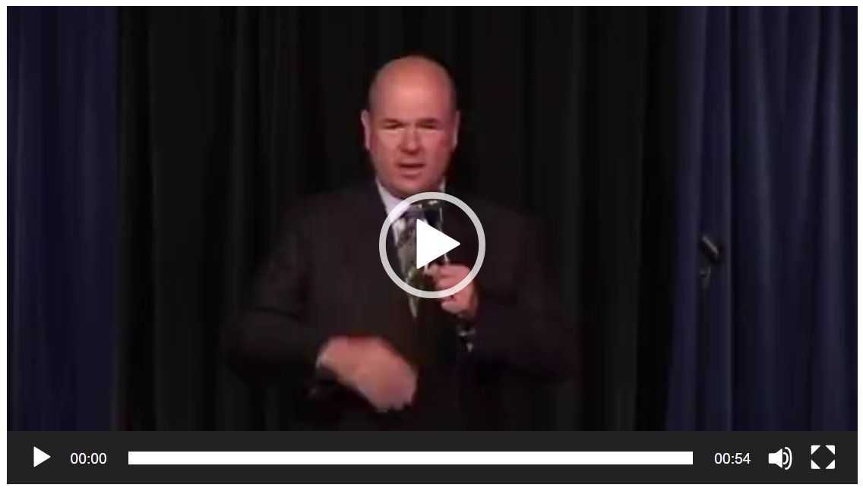
**Larry Miller clip**
In the space of about a minute he lays out the universal scenario for scarcity: on one hand, the want or need for a good or service and, on the other hand, the lack of resources to make or to trade for the good or service being sought. And the good news didn’t stop there. He boldly went on to proclaim the final piece of the puzzle, the fact that often the scenario doesn’t have a happy ending and the desire remains frustrated and unfulfilled.
It is that last point, that denial of many of our wants is inevitable, which modern thought finds disturbing. So disturbing, in fact, that many of us delude ourselves in thinking that is just shouldn’t be this way.
Sure, it’s fun to laugh at his characterization of ‘people in Washington’ who, upon realizing that they can’t afford the Ferrari they very much want, choose to order not just a single red one but enough red ones so that every member of the House and the Senate (hence the number 535) can be seen cruising around Dupont Circle in theirs. But we should be careful about how far we throw our scorn, as these ‘people’ represent us and, as a quote attributed to H.L. Mencken says
**Democracy is the theory that the common people know what they want, and deserve to get it good and hard.**
We should be laughed right alongside these ‘people in Washington’ precisely because most of us think we ‘deserve’ not to have to say to ourselves “therefore I won’t get one.”
To illustrate this point, consider this brief anecdote. There was as old show that often aired on PBS called Economics USA, one of the many shows in the line of Annenberg CPB-funded educational programs (now branded under Annenberg Learner). The episode in question (now seemingly lost with the modern revision) compared and contrasted two men who had started on the assembly line. One of them accepted a position as a manager and moved up to a higher paying job but with greater responsibility. The other wanted to stay on the assembly line but begrudged the first one making more money than he did. This worker said something to the effect that “it wasn’t fair that those guys made more money” and he wondered why only they should have more when ordinary guys like him deserve “a boat and two houses” too. Okay, maybe not the height of comedy but the shear willful disregard made me laugh.
Perhaps this anecdote isn’t universal enough to convince the skeptical reader. Consider this brief clip from the Charlie Brown Christmas in which Sally, Charlie’s younger sister, asks her older brother to help her write a letter to Santa. After some polite if perfunctory remarks to that jolly old elf, Sally’s dictation takes a “commercial” turn in which she begins listing all the things she deserves for Christmas and ends with the famous line “All I want is what I have coming to me! All I want is my fair share!”
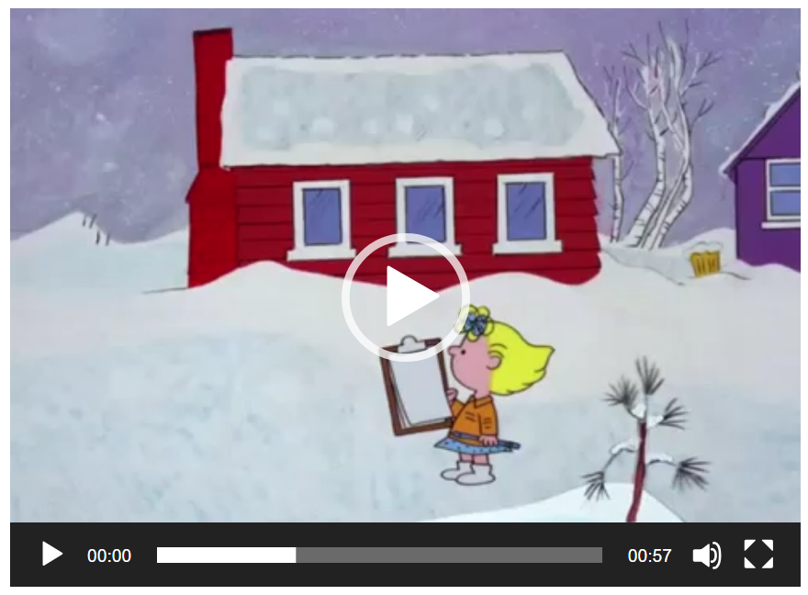
**clip**
There you have it: the entire tension in our modern economy is boiled down to the competition between “Therefore I won’t get one!” and “All I want is my fair share!”
Of course, in days of yore when people really were poor and labored in bad conditions, the rallying cry to get a fair share did have a moral spine. But in today’s advanced standard of living, it isn’t easy to side with Sally over Larry. Too often Sally’s position is simply a sanitized way of saying I want not only what my neighbors have (even if they worked harder than I did), I want more. And thus, envy rears its ugly head and green eyes.
I call it envy because it is frankly hard to call it anything else. The key to many decisions made by ‘rational actors’ in the economy seem to hinge far more making sure one comes out ahead of everyone else rather than that one has what one needs or has earned. And much of our modern life emphasizes it.
We see baseball players holding out for more money just to be able to brag that they have the bigger paycheck. We see people buying products they don’t need for more than they can afford just to ‘keep up with the Jones’. We see young people accumulating enormous levels of debt just to say they went to college. All throughout these examples the common theme of envy weaves its way through, and advertisers make sure to stir the pot by continuously pushing a message that is best summarized as an old radio thirty-second spot succinctly put it “You know you want it; you know you deserve it!”.
While I am sure I don’t know how to determine who deserves what, I am sure that we would all be a lot better off if we behave much more like Larry and far, far less like Sally.

